WEDE5020 PoE - Planning (Second website)

Organisation overview:
- Bakery – SweetyPies.
- History - A small bakery specializing in Boulangerie and Patisserie (Le Cordon Bleu, 2018).
Started as a small bakery, creating the most delicious treats for a small community; now they want to expand their territory into an online business for more exposure.
- Mission - They want to provide everyone with Boulangerie and Patisserie. Whether that be in-shop or online through orders
- Target audience – Busy professionals, families, and health-conscious shoppers (Zeely AI, 2025).

Website goals and objectives:

- Goals for website – The website should increase the number of customers for the bakery. It is being built specifically for exposure, as the bakery is still small, so it will provide information about the bakery and what they specialize in.
- Key performance indicators – According to Adeyemicovenant3 (n.d.), the following KPIs are the ones a bakery may consider tracking:
- User onboarding efficiency
- Authentication success rate
- Account provisioning time

Proposed website features and functionality:

Tab section – Homepage, About Us, Contact Us, Our Services.
Homepage – The homepage will include a short description of what they do at the bakery.
About Us – This section of the website will explain the history of the bakery and where it all started.
Contact Us – For any queries and custom-made desserts.
Our services – A few examples of what has been made at the bakery, with prices where they can order a replica of the item. It will be displayed in a menu format.

Design and User Experience:

- Colour scheme:
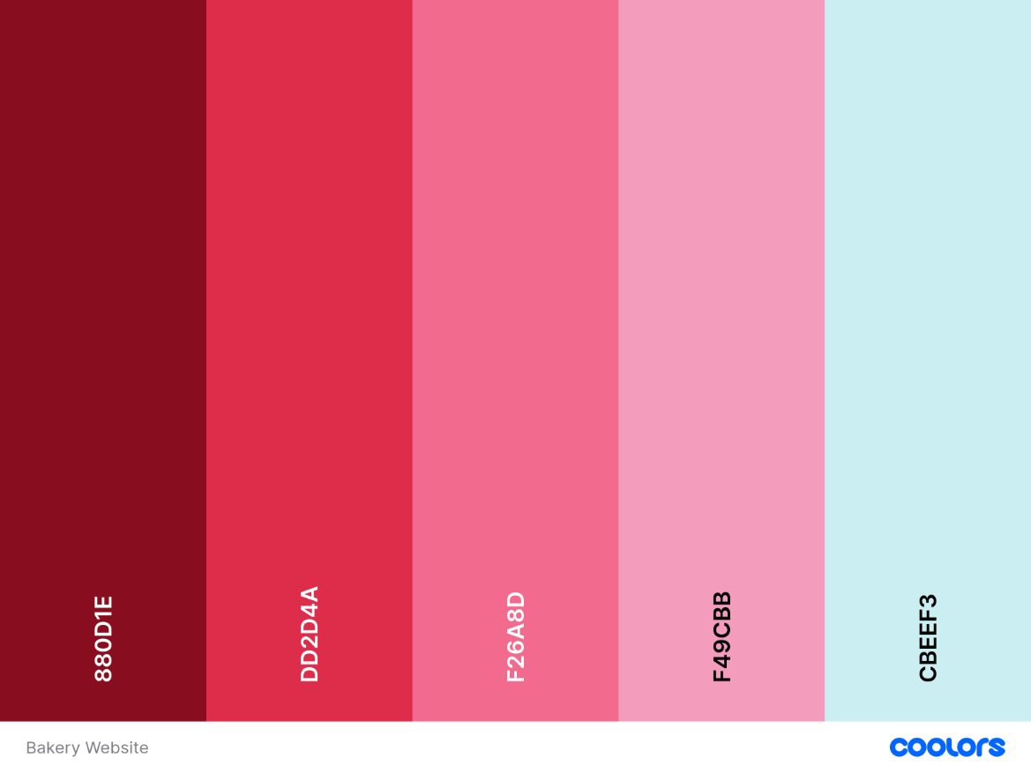

- Typography:
The typography styles I will use are serif and sans-serif (Adobe, n.d.).

- Layout and Design:
The layout would be simple. The layout direction would be Homepage, About Us, Contact Us, and Our Services. For the design, we will use the top theme, keeping it warm and cozy in colour.

- User experience:
Keeping UI and UX design in mind, I will build an easy-to-use interface for each page of the website. Keeping it mobile-web-friendly and PC-web-friendly. When a user clicks on a product, it will be added to the query box on the Contact us page, where they can insert their email and personal info. When they submit it will send an email to the bakery.

- Low-fidelity wireframes and Hierarchy.

Homepage:
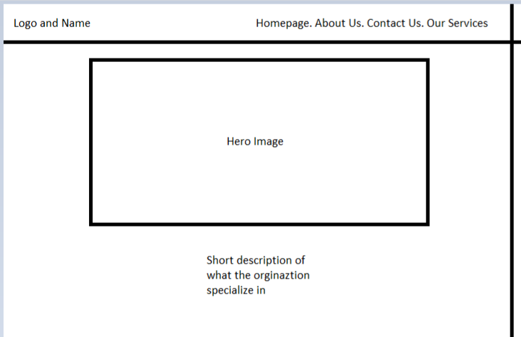

About Us:
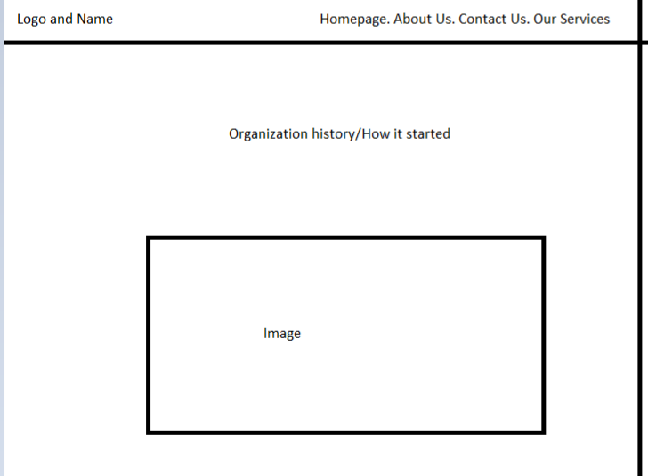

Contact Us:
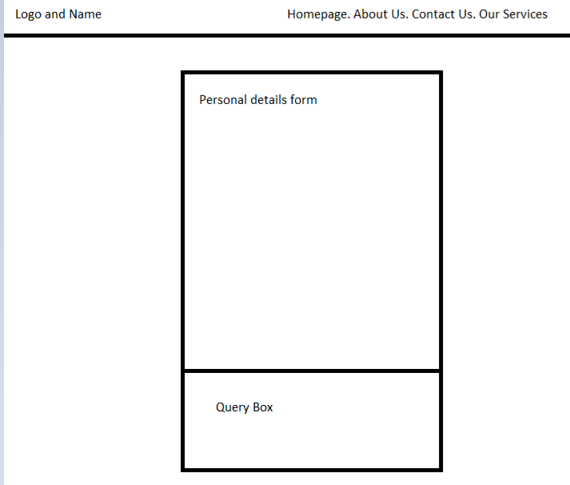

Our Services:
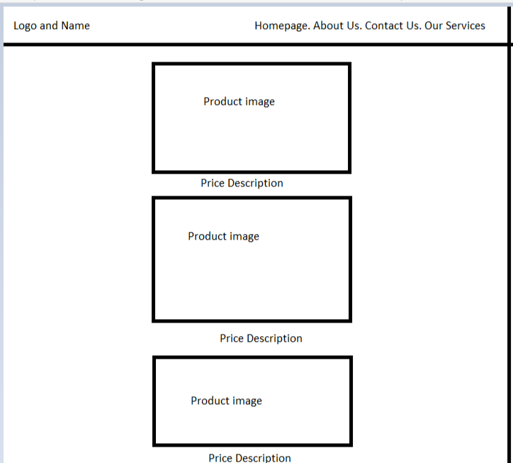

Technical Requirements:
Hosting – HostAfrica Link: https://hostafrica.co.za/domains/tld/co-za/ (R100 P/m)
Domain name – www.SweetyPies.co.za Link: https://hostafrica.co.za/domains/tld/co-za/ (R110 P/y)
Programming language – HTML, CSS, JavaScript

Timeline and Budget:
Development Timeline and Budget:
Timeline – 3 to 4 Months. Month 1 would focus on HTML. Months 2- 3 would focus on CSS and JavaScript. Month 4 would focus on testing before full deployment.
Budget – One-off payment R6500.00. Thereafter R600 p/m for maintenance and Hosting.

References:
- Le Cordon Bleu, 2018. What are pâtisserie, boulangerie and viennoiserie? Le Cordon Bleu, 25 September. Available at: https://www.cordonbleu.edu/news/what-are-patisserie-boulangerie-viennoiserie/en [Accessed 3 August 2026].
- Zeely AI, 2025. Proven bakery marketing ideas and strategies you can use in 2026. Zeely AI, 24 September. Available at: https://zeely.ai/blog/proven-bakery-marketing-ideas-and-strategies/ [Accessed 4 August 2026].
- Adeyemicovenant3, n.d. Key Performance Indicators for Bakeries [CMS Project]. Scribd. Available at: https://www.scribd.com/document/707995858/CMS-PROJECT [Accessed 4 August 2026].
- Adobe, n.d. The different styles of typography. Adobe Creative Cloud. Available at: https://www.adobe.com/za/creativecloud/design/discover/typography.html#the-different-styles-of-typography [Accessed 4 August 2026].

